DONaid

DONaid is a full-stack web application designed to facilitate them donations by allowing users to securely log in, list items with images, browse available donations, and communicate in real time through an integrated messaging system.
  - Donation Marketplace

Version Control | Written by | Date
1.0 | Justina Bosco | 29 March 2026

Table of Contents
1. Introduction 3
1.1 Purpose 3
1.2 Problem Statement 3
1.3 Project Objectives 3
1.4 Stakeholders 3
2. Product Description 4
2.1 User Stories 4
2.2 Architecture Diagram 4
2.3 Wireframe Design 5
2.4 Technology Stack 6
2.5 Database Design 6
2.6 Functional Requirements 6
2.7 Non-Functional Requirements 7
2.8 Out of Scope 7
3. Testing Strategy 7
4. Project Planning 8
5. End-to-end Solution 8
6. References – Project Dependencies 8

Introduction
DONaid is a web-based donation marketplace that allows users to list unwanted items for donation and connect with others through in-app messaging. The application focuses on reducing waste, supporting community reuse, and simplifying donation coordination through a single platform.

1.1 Purpose
This application is designed to connect individuals who wish to donate items with those who are seeking them. While existing platforms such as Facebook Marketplace offer similar functionality, they often include distractions and features unrelated to the donation process. This application provides a streamlined, purpose‑built environment focused solely on facilitating meaningful exchanges between donors and recipients.

1.2 Problem Statement
Usable household items are frequently discarded simply because donors lack convenient or coordinated tools to pass them on. Existing donation efforts are scattered across social media platforms, messaging apps, and other informal channels, making the process inefficient and difficult to manage. Additionally, current donation workflows often lack transparency and structure, creating barriers for both donors and recipients.

1.3 Project Objectives
This project aims to provide a streamlined platform where users can easily list items for donation, complete with images and essential details. It enables recipients to browse, search, and filter available items efficiently. The application also supports secure, item-specific communication through real-time messaging, ensuring smooth coordination between donors and recipients. To maintain integrity and security, only the original item owners are permitted to update or remove their listings.

1.4 Stakeholders
The primary stakeholders include donors, who contribute items for others to use, and recipients, who browse available listings and contact donors to request items. Community organisations represent potential future stakeholders who may use the platform to support their outreach efforts. The project owner is responsible for overseeing development, testing, deployment, and documentation of the application.

Product Description

2.1 User Stories
# | Role | User Story Description | Priority
1 | Donor | As a donor, I want to log in securely so that only I can modify my items. | P1
2 |  | As a donor, I want to list items with images and descriptions so that recipients can clearly understand what I’m offering. | P1
3 |  | As a donor, I want to edit or delete my own listings so I can keep my available items up to date. | P1
4 |  | As a donor, I want to receive messages from interested recipients so I can coordinate item pickup or delivery. | P1
5 | Recipient | As a recipient, I want to browse available items so I can find what I need. | P1
6 |  | As a recipient, I want to search and filter items so I can narrow down results based on category or name. | P1
7 |  | As a recipient, I want to message donors directly about specific items so I can ask questions or arrange collection. | P1
8 |  | As a recipient, I want to view item details and images so I can decide whether the item meets my needs. | P1

2.2 Architecture Diagram
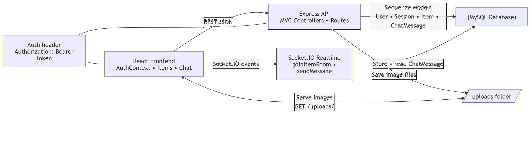

2.3 Wireframe Design
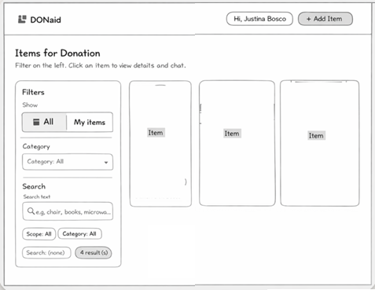
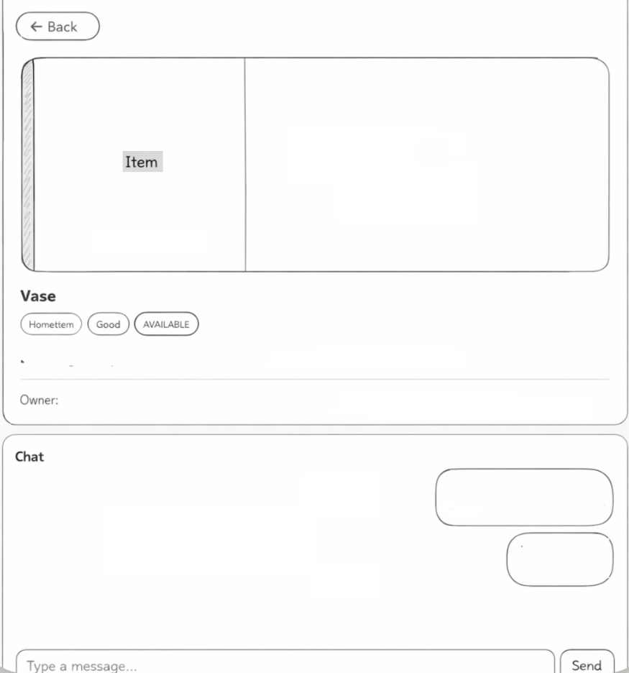
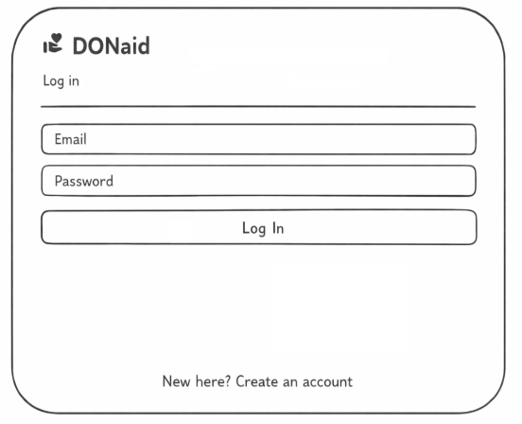

2.4 Technology Stack
- Frontend: React (Vite), Material UI (MUI), Context API
- Backend: Node.js, Express.js (MVC)
- Database: MySQL with Sequelize ORM
- Real-time Communication: Socket.IO
- Testing: Jest and Supertest

2.5 Database Design
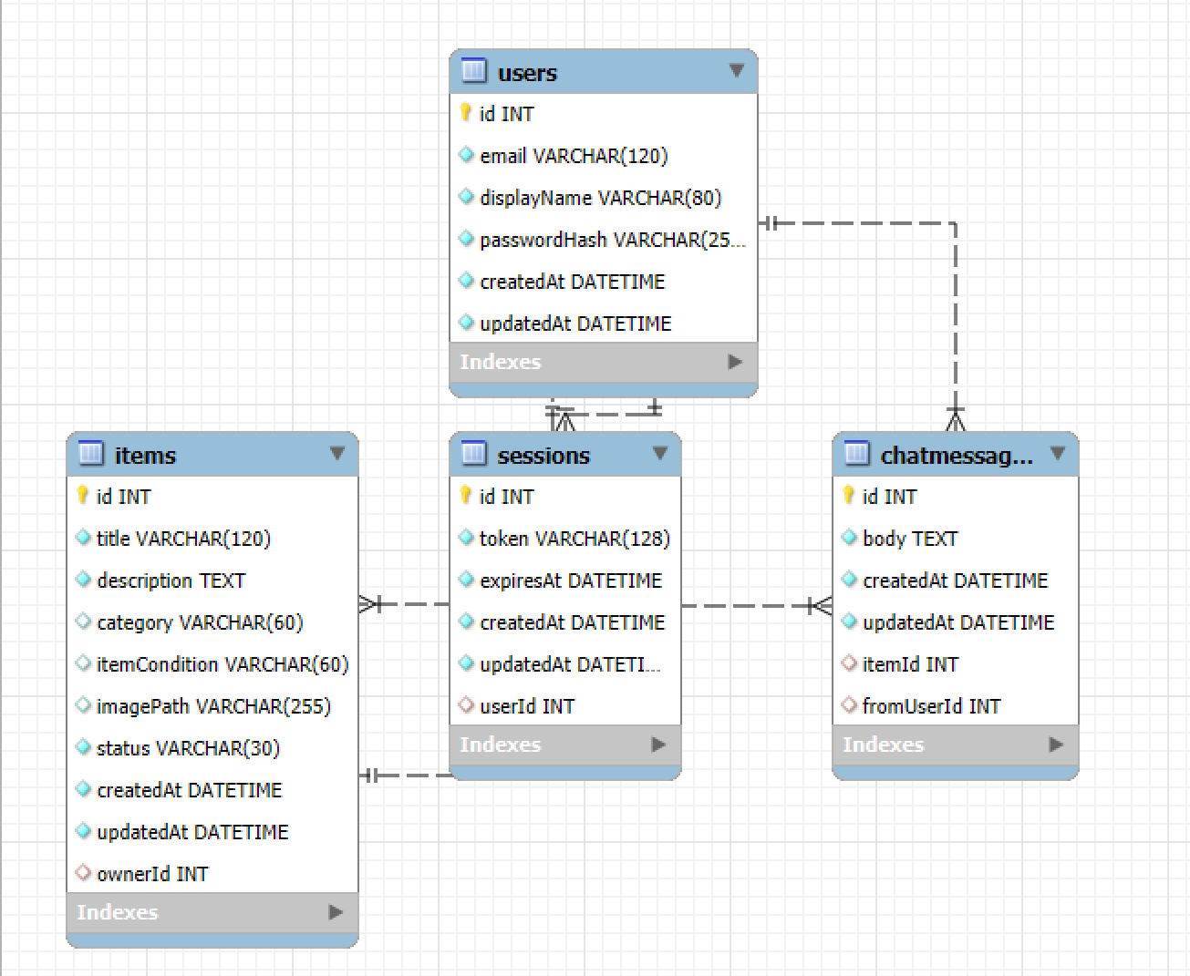

2.6 Functional Requirements
- User registration and login with secure password handling.
- Create, view, update, and delete donation item listings.
- Upload and display item images.
- Browse, search, and filter items by category and keywords.
- Real-time messaging between users about specific items.
- Owner-only permissions for editing and deleting items.

2.7 Non-Functional Requirements
The system emphasizes strong security by storing passwords as salted hashes, enforcing authenticated routes through valid session tokens, and applying strict authorization rules to prevent unauthorized item modifications. Usability is supported through a responsive Material UI interface, intuitive navigation with a filter sidebar and detailed item pages, and consistent feedback for both errors and user actions. To ensure long-term maintainability, the project follows clear separation of concerns with an MVC backend, uses modular React components and context providers on the frontend, and incorporates automated tests to reduce regressions and support ongoing development.

2.8 Out of Scope
Email notification: App is unable to send email notification upon adding/deleting items and receiving messages.
Auto logout: Auto logout is not part of the design as it helps users in remaining logged in

Testing Strategy
Testing was conducted using Jest and Supertest to validate backend functionality and business rules. A separate test database was used to ensure isolation from development data.
- Authentication tests: register, login, invalid credentials.
- Item CRUD tests: create, list, update, delete.
- Authorization tests: owner vs non-owner actions.
- Coverage reporting generated using Jest coverage tools.

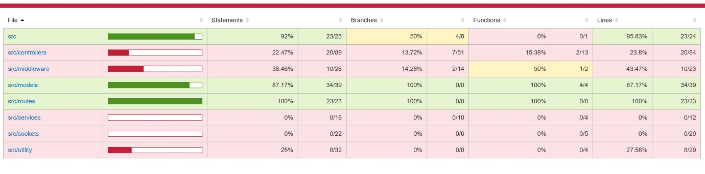

Project Planning
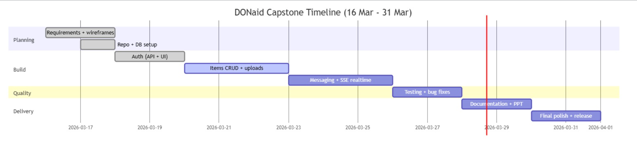

End-to-end Solution
DONaid successfully delivers a functional donation marketplace with secure authentication, item management, and real-time communication. The project demonstrates full-stack development skills, effective use of modern frameworks, and the importance of testing and documentation in delivering a reliable application.

References – Project Dependencies
- Express.js
- dotenv
- Sequelize(Object Relational Mapper)
- mysql2
- React
- Socket.io
- MySQL Workbench

